User testing on your final project wireframes

Due 12/5 or 12/7

Please launch two a user testing on the final project website you designed with [www.usertesting.com](http://www.usertesting.com/).

You need to

* Test your design with 1 mobile phone user and 1 desktop user. You need to create two tests on UserTesting
* Write a report similar to the individual assignment 6 baseline test report. You need to include the links to your wireframes and usertesting videos in the report. Please see the attached template.
* Present your final design and user testing results in class on 12/5 and 12/7

Check the instruction document for wireframe 1 on how to share with two flows in Adobe XD. If you cannot share multiple flows, you can create two xd files, one for mobile and one for desktop. Then share them separately! If Adobe XD does not allow you to share, make sure you sign in with your ilstu email. If it still does not work, please send me your final adobe XD files, and I will share for you. When you share your links in adobe xd, choose the "user testing" view setting.

1. You should have already had an usertesting account for individual assignment 6. Login with the same account.
2. Create a test

Click “New” -> “Create test”

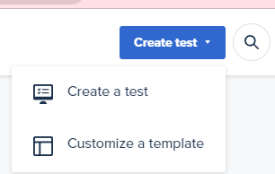

Choose Prototype to test

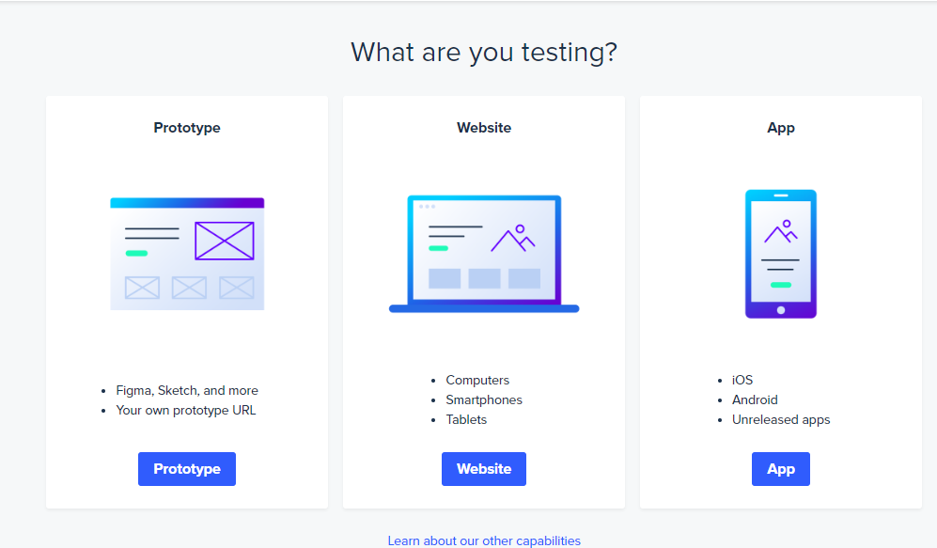

Select Audience

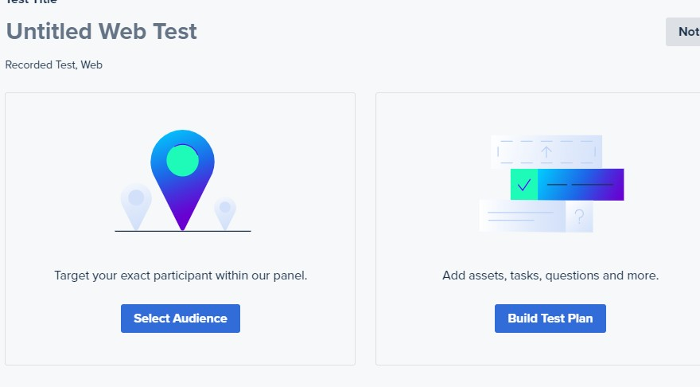

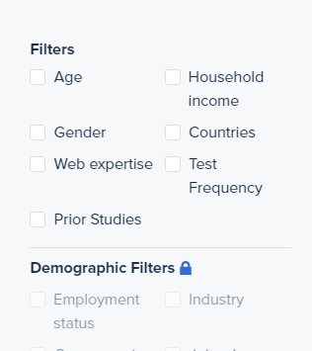You will test your design on a computer and a mobile phone, which means you need to create 2 tests in UserTesting with 1 participant for each test. You can use the same questions for the two tests.

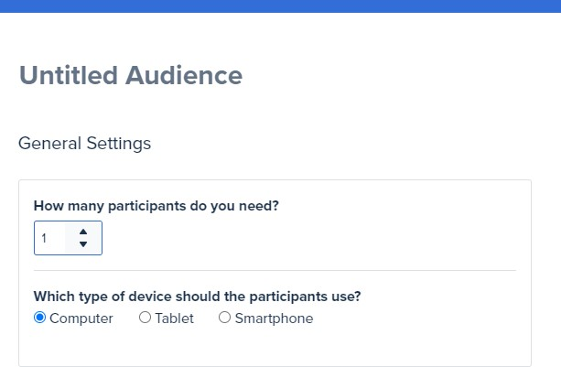

You can add filters if you want to. If you see a lock icon, it means you need to upgrade your account to have access to the functions. Do not upgrade! You do **not** need to pay for any assignments for this course.

Click “Done” at the bottom of your screen

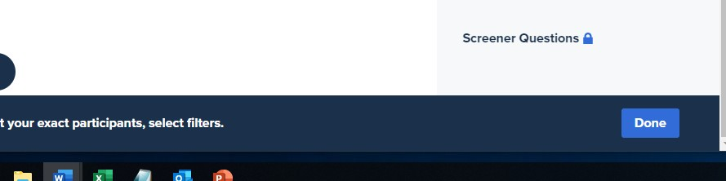

“Build Test Plan”

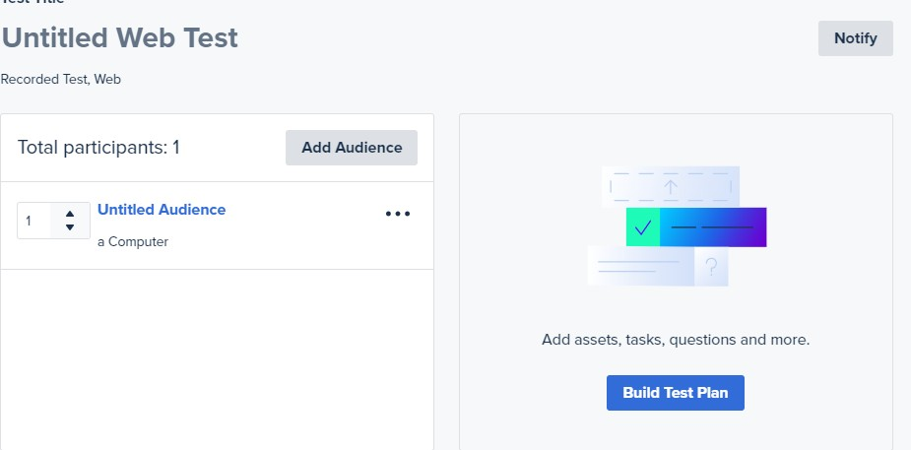

Add your Adobe XD sharing URL, and add a scenario for your test. You need to create two tests. 1 for mobile and 1 for desktop. You have two URLs, 1 for mobile phone, and 1 or desktop. Make sure you enter the correct one for each test.

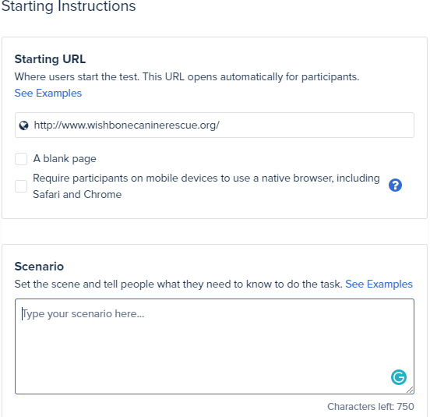

Add **at least 12** tasks and questions to your test plan. Check the “online usability testing” slides in the week 8 folder for task and question examples. Make sure your questions are clear. You can reuse your questions for individual assignment 6.

You can ask your participants to compare your design with the current website if you want to.

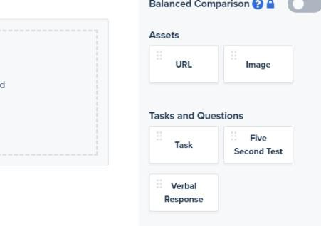

You can enable “Include post-test questionnaire”, which is considered as one task.

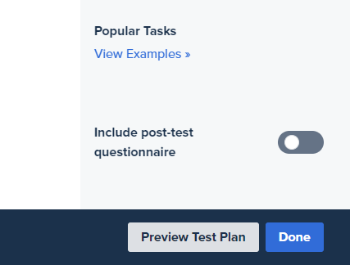

**Preview Test Plan. Make sure everything works. Make sure the right url is used for each test. Preview with the right device for each test.**

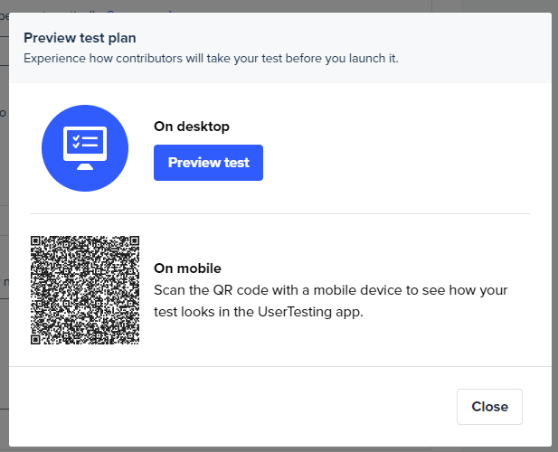

If everything looks correct, click “Launch test”

Participants will pick up your project. When the studies are done, you will receive two videos. Please analyze the videos and report your findings. A report template is attached.

Make sure you add the links to the usertesting videos in the report.

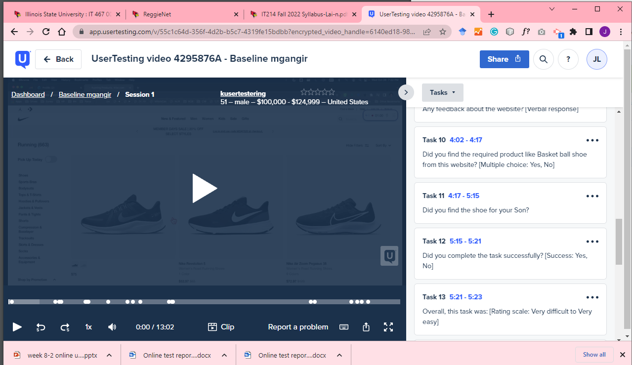

Change “viewable by” into “Anyone with the link”

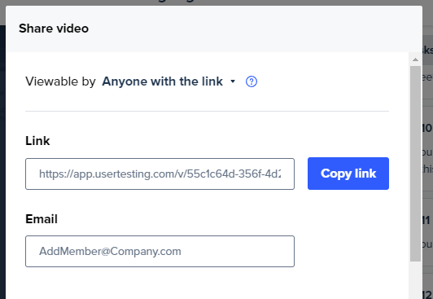

Please submit your adobe xd file, adobe xd share links, and the user testing report to Reggienet by 12/7.